Phase 4 : Requirement Analysis

In this phase, the needs of users and stakeholders are gathered and analysed. Key requirements are identified, such as restaurants needing a simple way to upload leftover food details and NGOs requiring quick notifications about available food. This helps define what the system should do before designing and building it.

Milestone 8 : PROFILES :-
- Go to setup page >> type Profiles in Quick Find bar >> click on Profiles >> click on ‘S’
- Click on Clone beside Standard Platform User.
- Under Clone Profile:
Profile Name : NGOs Profile
- Then click on Save.

Milestone 9 : CREATION OF USERS :-
In our Project we consider them as NGO’s.

Activity 1: Creation of User1 :-

- Go to setup page >> type users in Quick Find bar >> click on users>> New user.
- In General Information give details as: (Note : create users as per your wish NGO’s)
  - First Name : Iksha Foundation
  - Last Name : Iksha_Foundation
  - Alias : iiksh
  - Email : Give Your Email
  - Username : ikshafoundation@sb.com (give the username different)
  - Nickname : Auto Populated
  - User License : Salesforce Platform
  - Profile : NGOs Profile
  - Active : Check

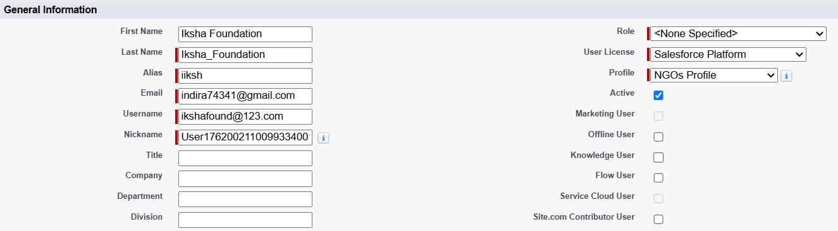

- Click on Save.

Activity 2 : Creation of User2 and User3 :-

- Create another Two Users by following steps in Activity - 1 with similar User License and Profile.
- Give Different First Name, Last Name based on Different NGO’s.

Milestone 10 : PUBLIC GROUPS :-

Activity 1 : Creation of Public Group 1 :

- Go to setup page >> type Public Groups in Quick Find bar >> click on Public Groups >> click on New.
- Under Group Information:
  - Label : Iksha
  - Group Name : Iksha
  - Grant Access Using Hierarchies : Check
- In Search, Select Users.
- In Selected Members Add Iksha Foundation.

Activity 2 : Creation of Public Group 2 and 3:-

- By Following Steps in Activity 1, Create other two Public Groups for other two users.
- After Saving this would look like this.

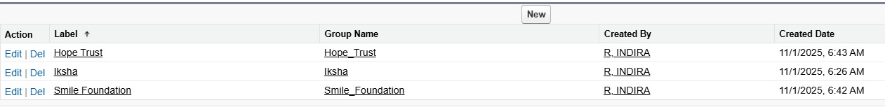

Milestone 11: REPORT TYPES :-

Creation of Venue with DropOff with Volunteer Reports :-

- Go to setup page >> type Report Types in Quick Find bar >> click on Report Types >> click on Continue >> Click on New Custom Report Type.
- In Define the Custom Report Type:
  - Primary Object : Select Venues
  - Report Type Label : Venue with DropOff with Volunteer
  - Description : Venue with DropOff with Volunteer

  - Store in Category : Select Other Reports
  - Deployment Status : Deployed
- Click on Next
- Near Click to relate another Object Select Drop-Off Points.
- And also select "A" records may or may not have related "B" records.
G. Now again Near Click to relate another Object Select Volunteers.
7. Now click on Save.

Milestone 12 : REPORTS :-

Activity 1 : Creation of Report on Venue with DropOff with Volunteer :-

- Go to the app(FoodConnect) >> click on the reports tab
- Click on New Folder.
  - Folder Label : Custom Reports
  - Folder Unique Name : CustomReports
- Open Custom Reports and click on New Report
- Select Report Type : Venue with DropOff with Volunteer
- Then click on Start Report.
G. In GROUP ROWS : Add Volunteer Name
- In Columns : Add Venue Name, Drop-Off point Name, Distance.
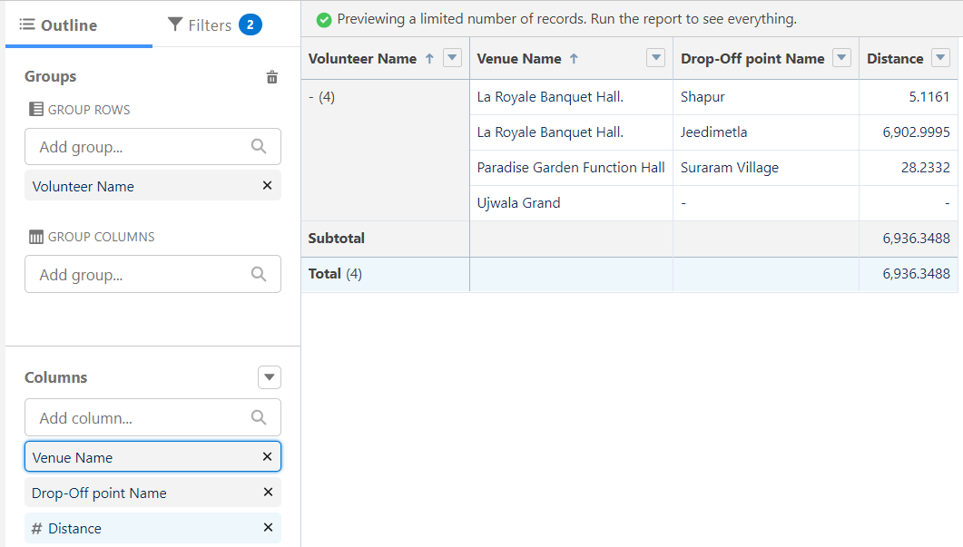

- Now click on Save & Run.
- Give Label as :
- Report Name : venue and Drop Off point
- Report Unique Name : Auto Populated
- Click on Select Folder and select Custom Report, then click on Save.

Activity 2 : Creation of Report on Volunteers with Execution Details and Tasks :-

- Go to the app(FoodConnect) >> click on the reports tab
- Click on Custom Reports Folder and click on New Report
- Select Report Type : Volunteers with Execution Details and Tasks.
- Then click on Start Report.
- In GROUP ROWS : Volunteer ID
G. In Columns : Add Volunteer : Volunteer Name, Task : Task Name, Execution Detail Name, Created Date.

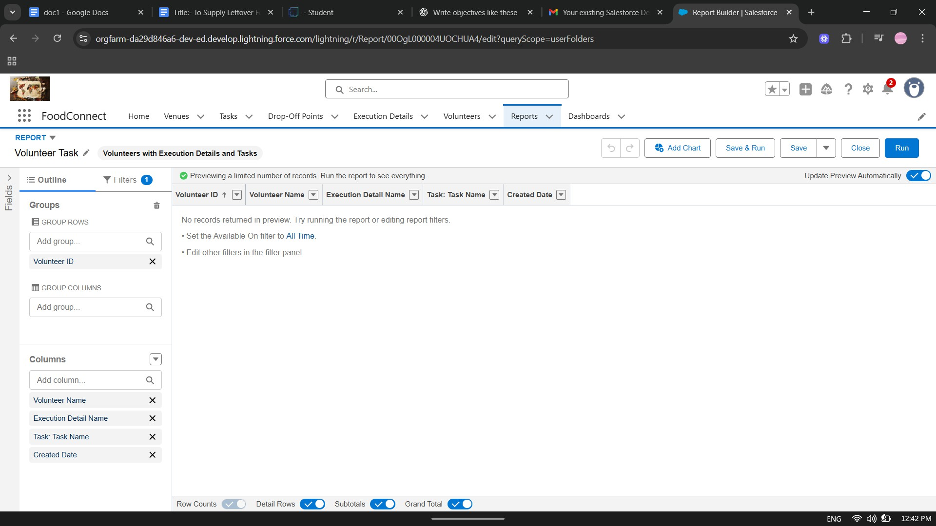

- Now click on Save & Run.
- Give Label as :
  - Report Name : Volunteer Task
  - Report Unique Name : Auto Populated
- Click on Select Folder and select Custom Report, then click on Save.

Milestone 12 : DASHBOARDS :-

Activity 1 : Adding venue and Drop Off point Report to the Dashboard :-

- Go to the app(FoodConnect) >> click on the Dashboards tab.
- Click on New Folder.
  - Folder Label : Custom Dashboards
  - Folder Unique Name : Auto Populated
- Open Custom Dashboards and click on New Dashboards
- Name : Organization Details
- Click on Widget and select Chart or Table
G. In Select Report : Select venue and Drop Off point Report.
- Then click on select
- In Add Component:
  - Display As : Select Lightning Table
  - Component Theme : Select Dark (Optional)
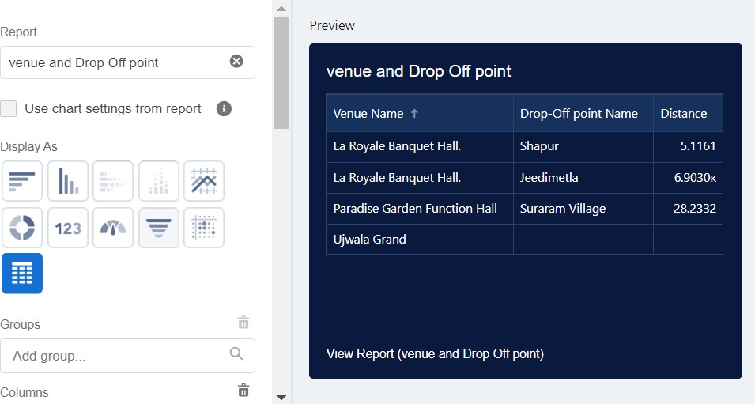
- Now click on Save.

Activity 2 : Adding Volunteer Task Report to the Dashboard :-

- Click on Widget and select Chart or Table
- In Select Report : Select Volunteer Task Report.
- Then click on select
- In Add Component:
  - Display As : Select Line Chart
  - Component Theme : Select Dark (Optional)
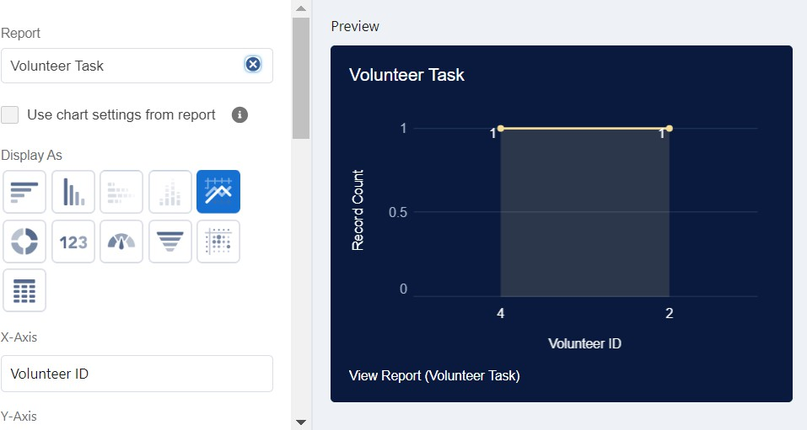
- Now Click on Save.

Activity 3: Adding a Picture to the Dashboard (Optional) :-

(Note : To upload an image into the Dashboard, we have to first download an image from google or other sources into your system)
- Click on Widget and select Image. Then click on Browse Files.
- Then Select the Picture you want to upload in this Dashboard.
- Then click on Save As :
  - Name : Task Execution Details

  - Click on Select Folder and select Custom Dashboards
- Click on Select Folder and then Save.
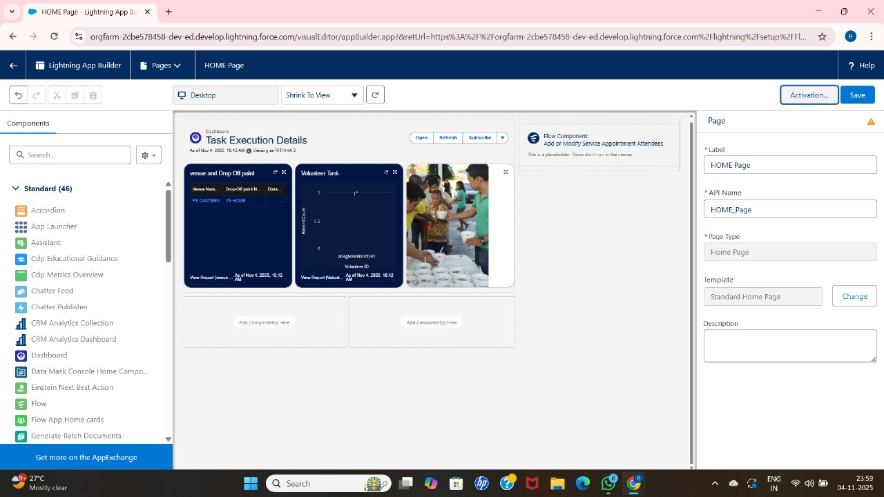

Milestone 13 : SHARING RULES :-
- Go to setup >> type Sharing Settings in quick find box >> Click on the Sharing Settings.
- Scroll down and find Drop-Off point Sharing Rules.
- Click on new near Drop-Off point Sharing Rules and Name it as:
  - Label : Rule 1
  - Rule Name : Rule_1
- Select your rule type : Select Based on criteria.
- Select which records to be shared:
  - Field : Operator : Value = Distance : less than : 15
G. Select the users to share with : Near Share With
- Public Groups : Iksha
- Click on Save.
- Click on new near Drop-Off point Sharing Rules and Name it as:
  - Label : Rule 2

  - Rule Name : Rule_2
- Select your rule type : Select Based on criteria.
- Select which records to be shared:

  - Field : Operator : Value = Distance : greater than : 15
  - Field : Operator : Value = Distance : less or equal : 30
- Select the users to share with : Near Share With
  - Public Groups : NSS
- Click on Save.
- Click on new near Drop-Off point Sharing Rules and Name it as:
  - Label : Rule 3
  - Rule Name : Rule_3
- Select your rule type : Select Based on criteria.
- Select which records to be shared:
  - Field : Operator : Value = Distance : greater than : 30
  - Field : Operator : Value = Distance : less or equal : 50 1G. Select the users to share with : Near Share With
  - Public Groups : Street Cause
17. Click on Save.
